she

COURSE: VDIT Diploma in IT
UNIT OF STUDY: VIT1202 Operating Systems ASSESSMENT TITLE: Practical Assignment – Part A ASSESSMENT TYPE: Assignment
Student name: Student ID:

Instructions:
- Enter your Name and Student ID above.
- This assessment needs to be completed individually.
- Refer to the rubric provided detailing all tasks to be completed and how marks are assigned.
- Plagiarism will not be tolerated. Copied work for practical assignment can easily be detected.
Mark breakdown
- Weighting: This assessment is worth 10% of your final result for this unit of study

Conditions
- This assessment is Open Book. You are free to use any resources or materials on VU Collaborate and any of your own summary notes.
- Time allowed for this assessment: 2 weeks or as specified by your teacher.
- You will be required to provide evidence of your solution in the form of a shell script file. Name your solution file shell_script_s9999999.sh where the digits represent your student ID.
- Your solution must be submitted to a specified drop box via VU Collaborate.
Resources
- PC or Laptop with Virtual Box Software installed
- Only one Virtual Machine (OVA) file: Centos 8.ova
  - user=rhauser, password=redhat
  - user=root, password=Redhat1@
- The OVA file will be provided by your teacher:
  - In the classroom these should be accessible from the T: Drive
  - In a remote environment a link will be provided to download the files.
- Notepad++ or Visual Studio Code or any enhanced editor with syntax colouring feature
- Nano terminal utility or GEDIT in the Linux Desktop environment.

Description of Tasks

You will be required to develop a UNIX based Shell Script to automate management tasks for a Linux Operating System. The solution will be a menu driven program that provides the systems administrator options to run the following automated tasks:

1 – Backup User Profile

The script should perform the following subtasks:

- Prompt the systems administrator for a username.
- Your program should not perform this option if the user account doesn’t exist on the system.
- Create a compressed archive as backup of user home directory contents.
- Save this archive to the backup directory. The backup directory should pre-exist in the username directory. If the backup directory doesn’t exist, create it in the username directory.
- The backup file should be uniquely timestamped. Use the universal date format.
E.g. 2023-08-06_1691303196-rhauser.tar.gz
- The script should display appropriate status messages that informs the systems administrator of the processes that are taking place for each task and indicate success or failure.

2 – Restore User Profile

The script should perform the following subtasks:

- Prompt the systems administrator for a username.
- Your program should not perform this option if the user account doesn’t exist on the system.
- Verify the backup file exists in backup directory for that username. If the file(s) don’t exist do not proceed with the restore task.
- Delete the contents of the restore directory in the username directory. If the restore directory doesn’t exist then create it.
- List all the backup archives in the backup directory in a menu format with numbered options to select.
- Allow the administrator to select the required backup archive, then begin the restore the process.
- Extract all files/folders from backup archive to the restore directory
- The script should display appropriate status messages that informs the systems administrator of the processes that are taking place and the success/failure of the tasks.

3 – Quit the program

The script should terminate when this option is selected.

Do not use sudo commands in your script. Login as root user to run and test your scripts.

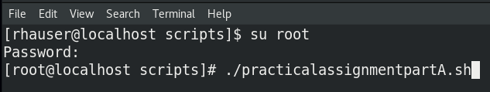

Create some Users to test the script:
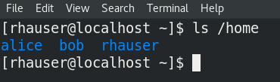
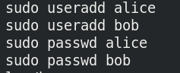

If you login as Alice or Bob, the system will create a set of sub-folders in the home directories. Alternatively you can add some files and sub-folders in their home directories using sudo command.

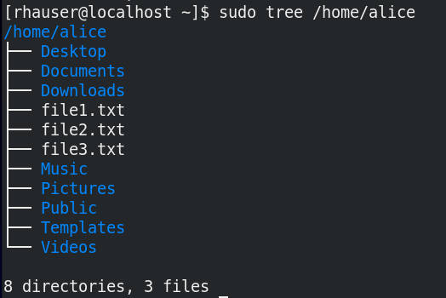

Program Outputs:

The script should display a suitable menu to allow the systems administrator to select an option. Once an option is selected then that task (all the sub tasks) is automatically performed by the script. The menu should then be redisplayed to allow the administrator to perform the next task.

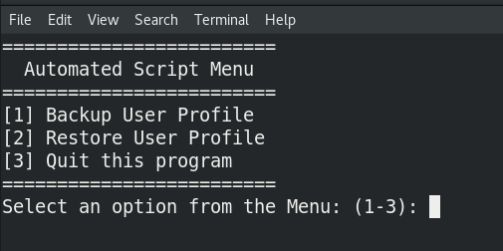

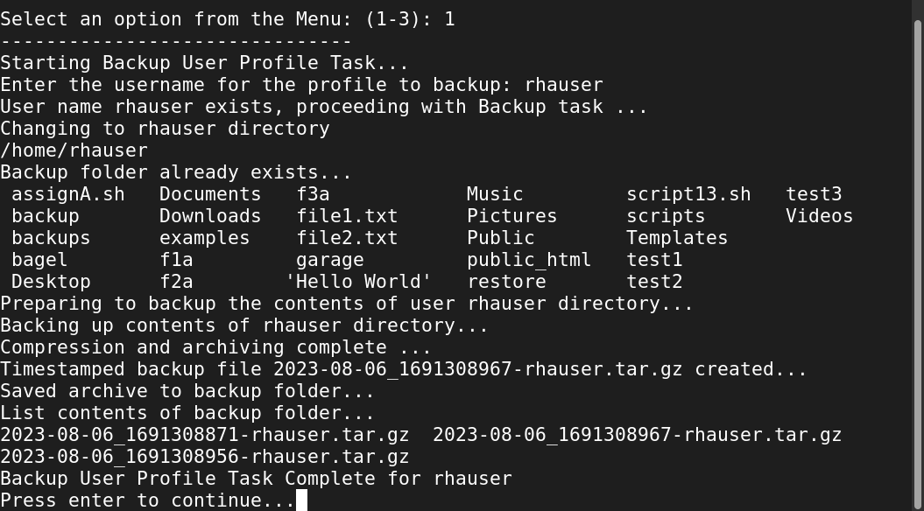

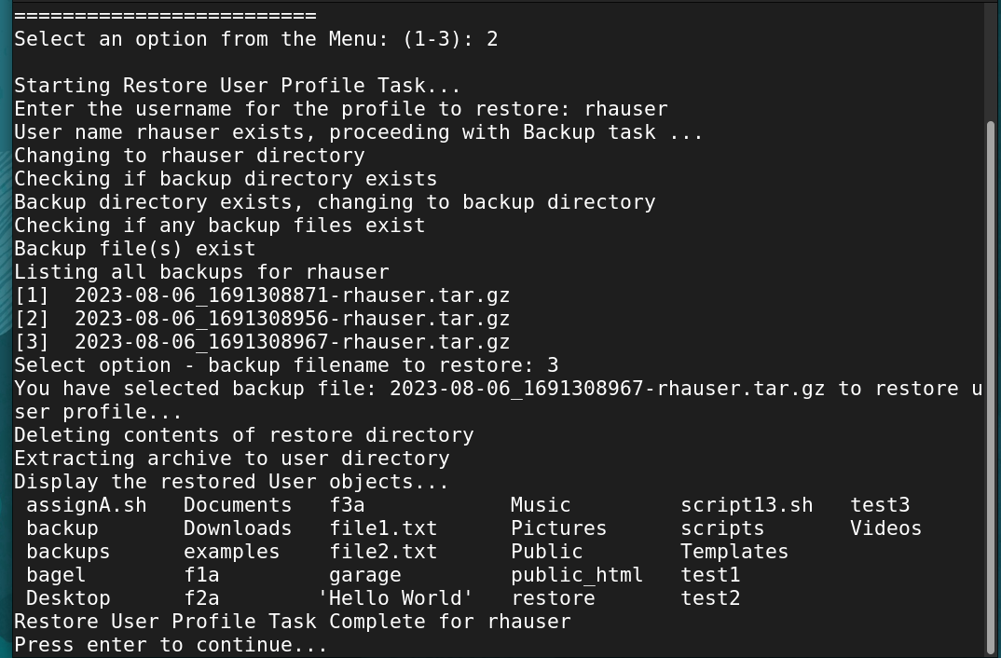

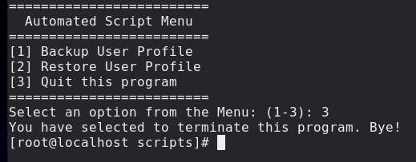

The script should display appropriate status messages that informs the systems administrator of the processes that are taking place and the success/failure of the tasks.

RUBRICS
Assessment Criteria | Possible Marks
Continuous Menu Display | 1
Script Code is Modular (functions are used for tasks) | 2
Appropriate Comments included | 1
1 – Backup User Profile
The script should perform 5 tasks for this option.  The script should display appropriate status messages that informs the systems administrator of the processes that are taking place and the success/failure of the tasks.  2 marks awarded for each performed task. | 10
2 – Restore User Profile
The script should perform 5 tasks for this option.  The script should display appropriate status messages that informs the systems administrator of the processes that are taking place and the success/failure of the tasks.  2 marks awarded for each performed task. | 10
3 – Quit Program
The script should terminate when this option is selected. | 1
Total Marks | /25
Total Weight | /10

